**20 Jan 2026**

### **1. Visualize the Capital Stack**

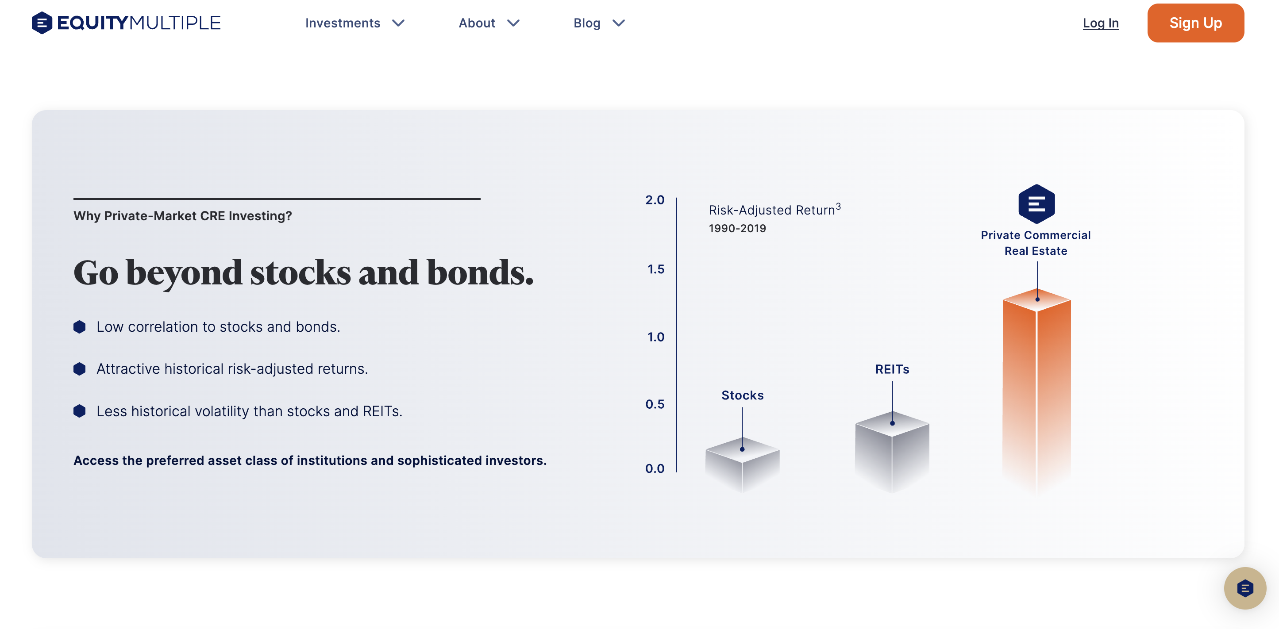

Investor structure you we details listing Senior Debt.

Problem is text based data is hard to understand. Investors need to instantly visualize their position relative to other capital.

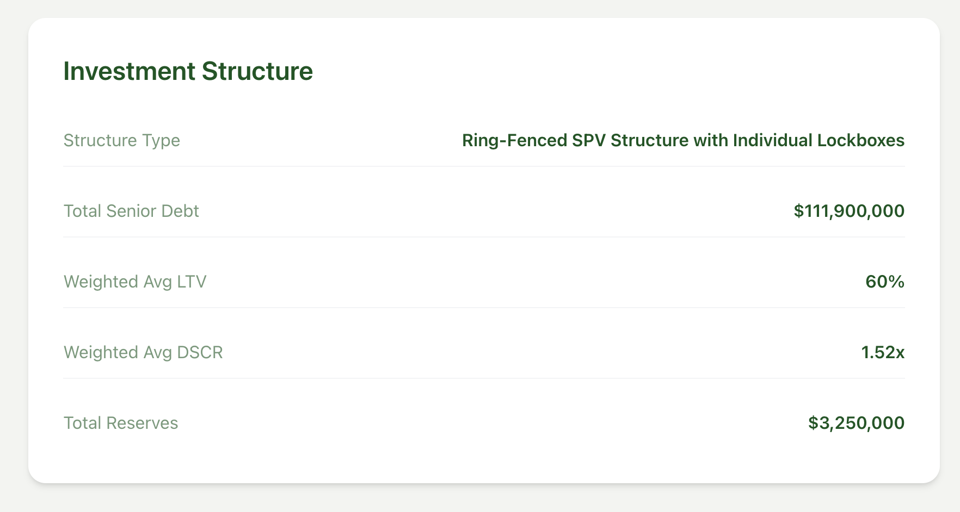

We can have a table with a Stacked Bar Chart (The Capital Stack).

Competitors like EquityMultiple and Centrifuge use this to visually prove that the sponsor absorbs the first losses, which is a massive trust signal.

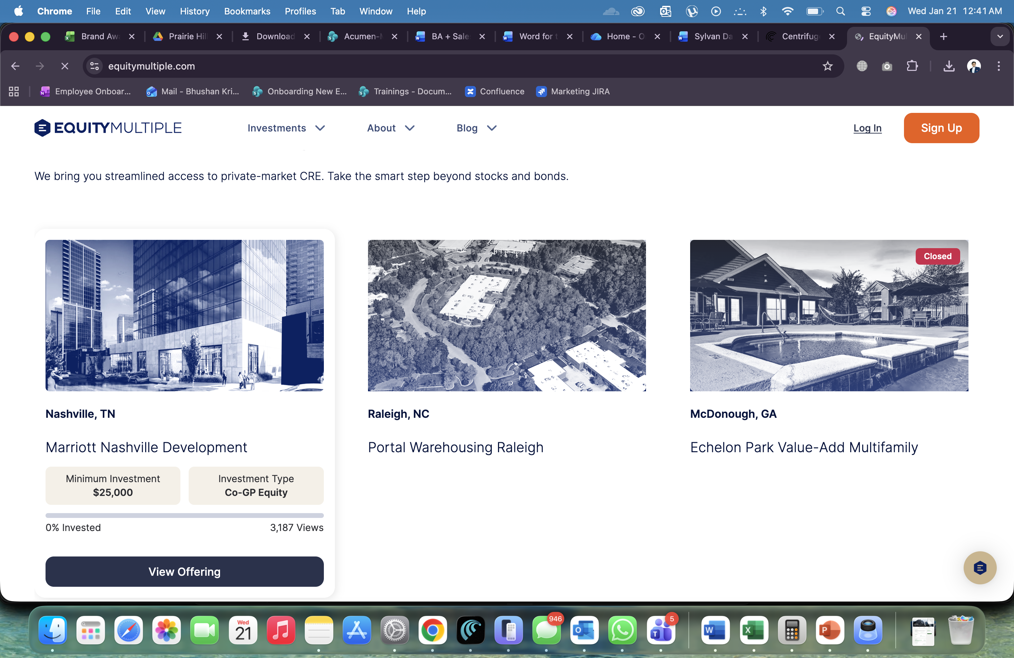

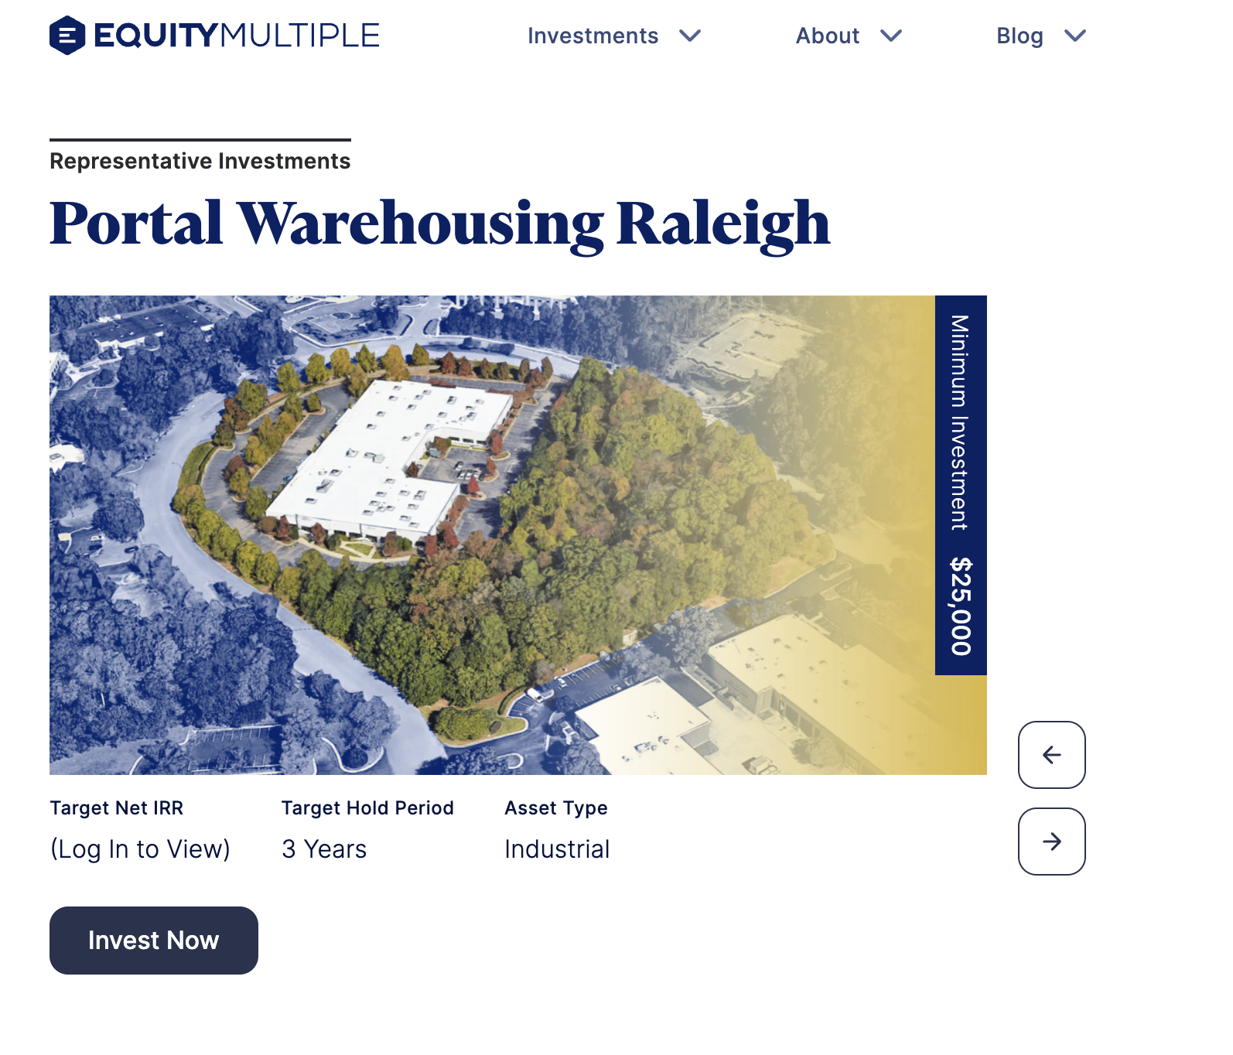

### **Sponsor Track Record Dashboard**

Investors bet on the manager ability to execute. I think logo is not enough. May be we can nsert a Sponsor Profile section between Portfolio Metrics and Asset Allocation.

Like we can show Key Metrics:

* + Total AUM: $500M+
  + Historical Performance: Avg. Realized IRR: 14%
  + In-House Management: Properties Managed: 45

### **Risk Factors & Surveillance Section**

We have Risk Diversification, which is a marketing benefit but thereis no disclosure of actual risks interest rate risk, vacancy risk. Most of our competitors yieldstreet, wilow wealth show these both.

* Tenant Concentration in Retail > Mitigant: Anchored by Investment Grade Tenants.
* Interest Rate Volatility > Mitigant: Fixed-rate Senior Debt locked for 5 years.

Listing page examples:

Below is willowwealth dashboard, they have good overview slide and filter module

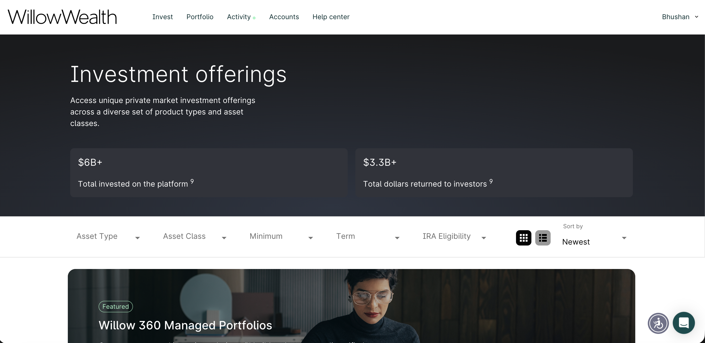

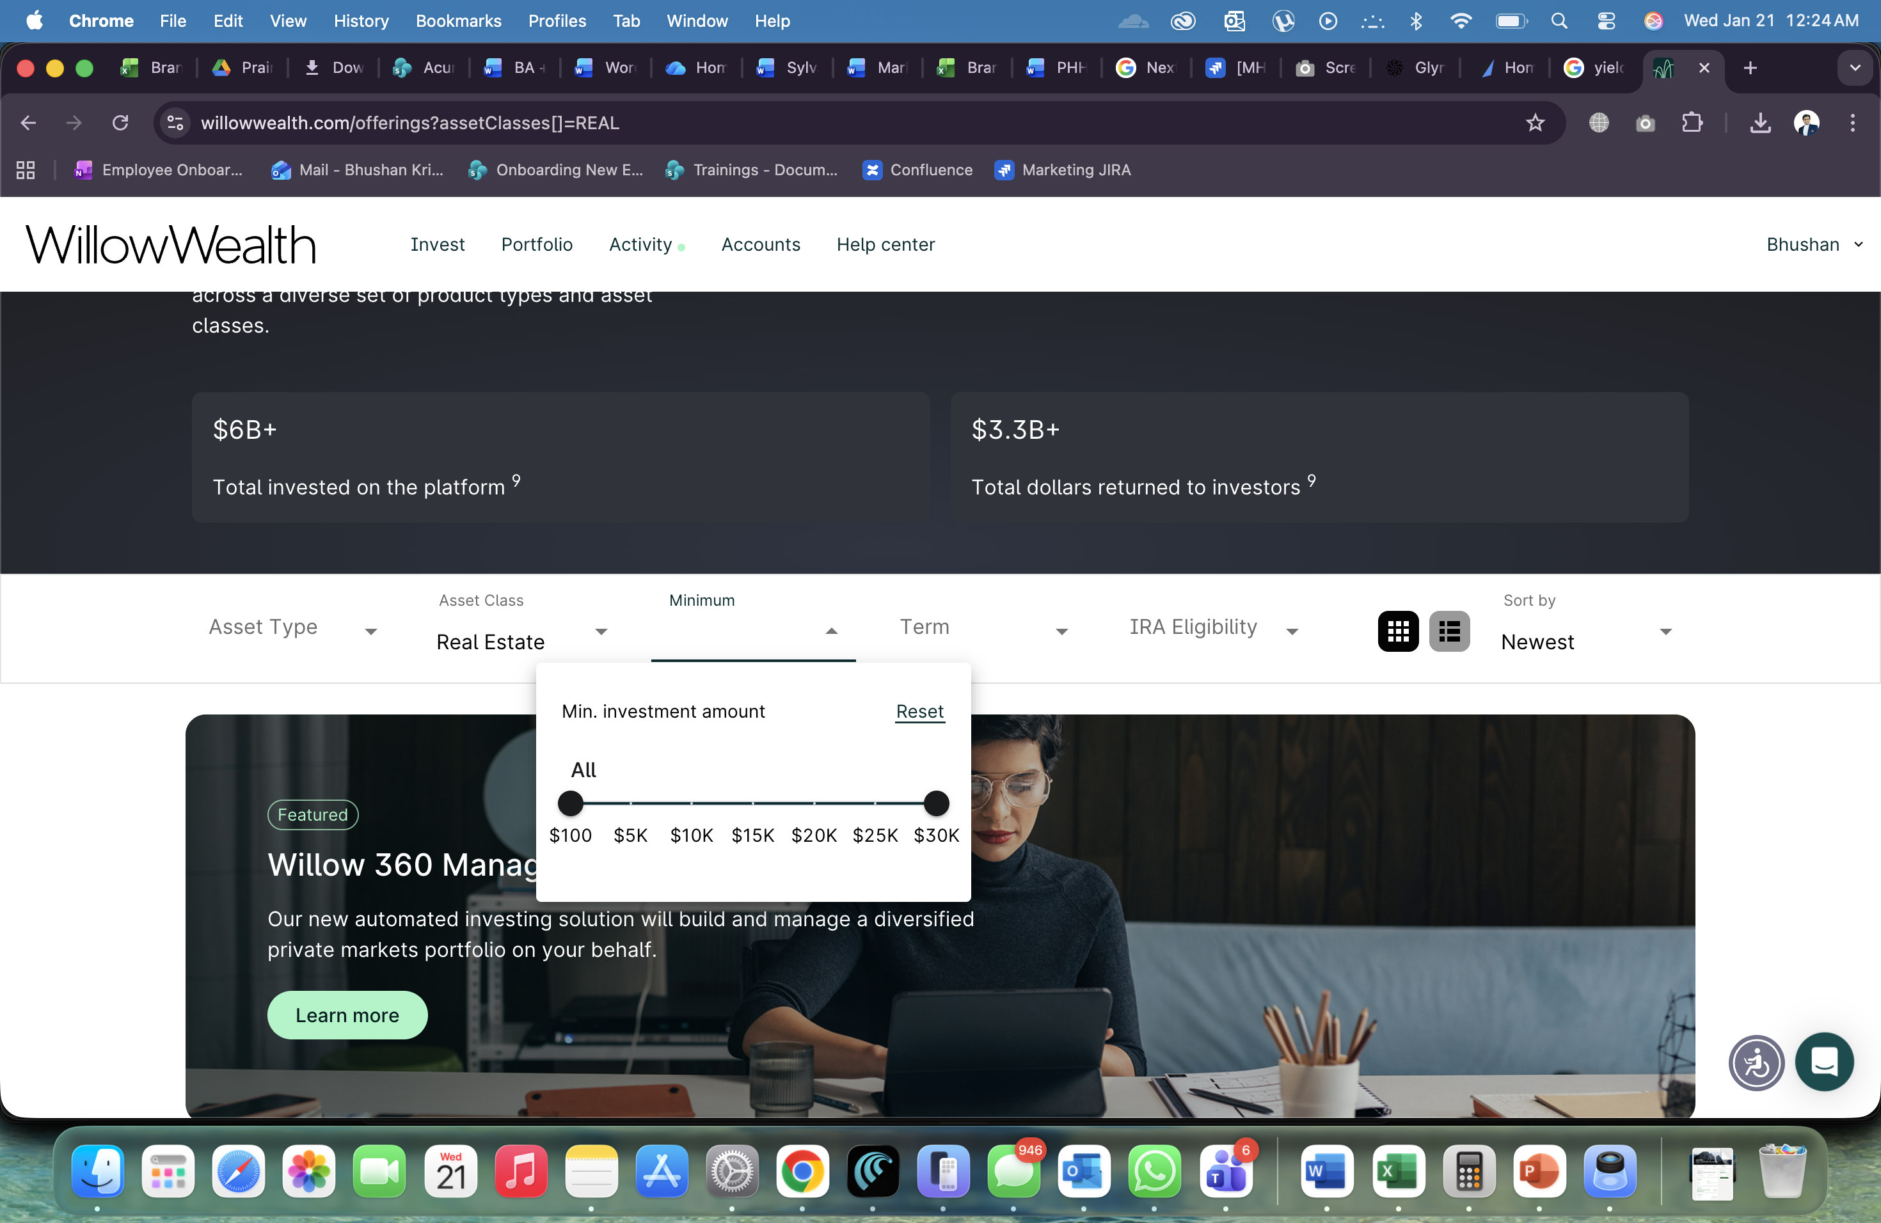

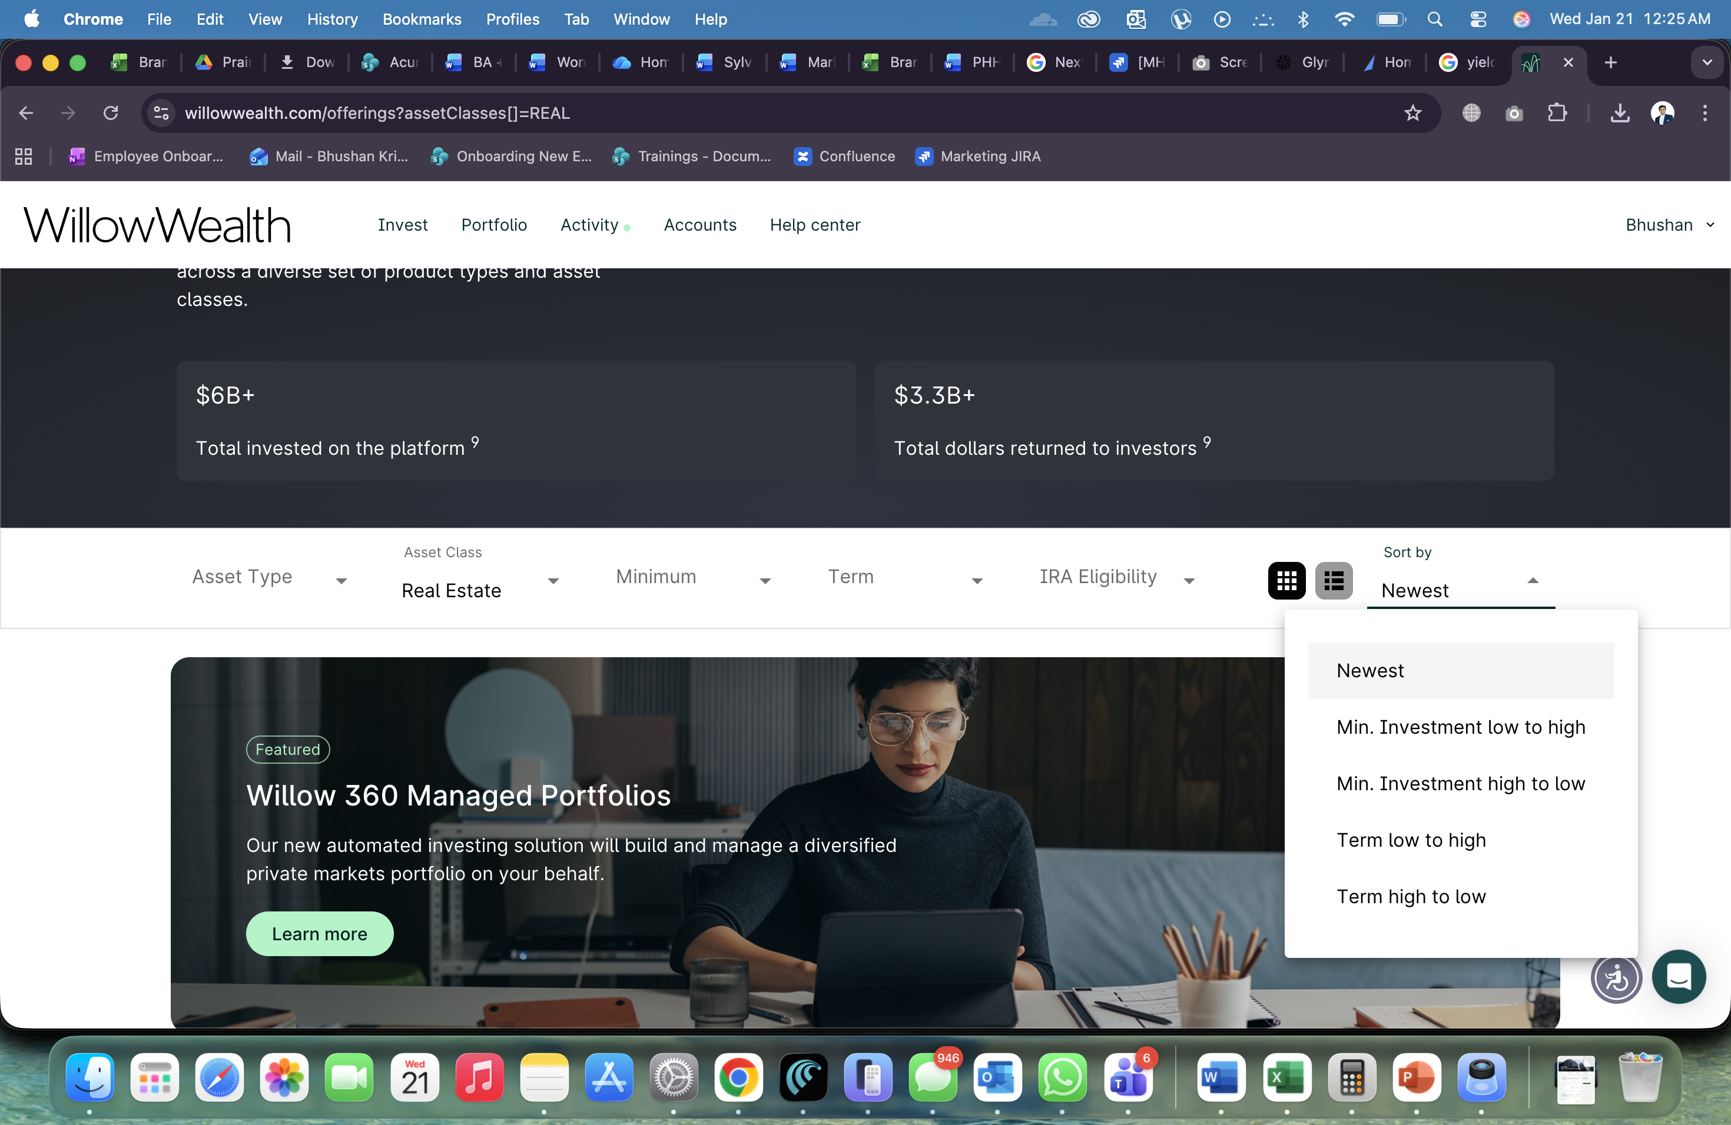

Equitymultiple hides most of key information until user creates an account

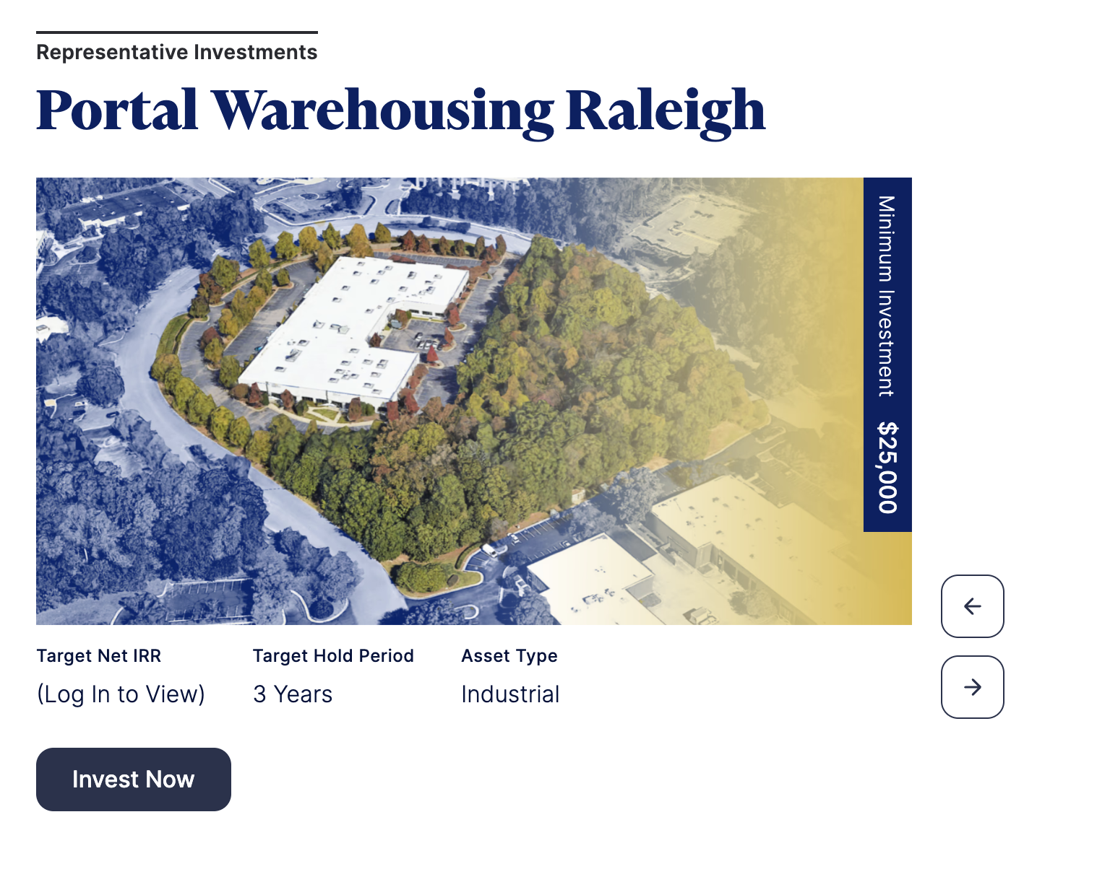

**Created on 16 JAN 2026**

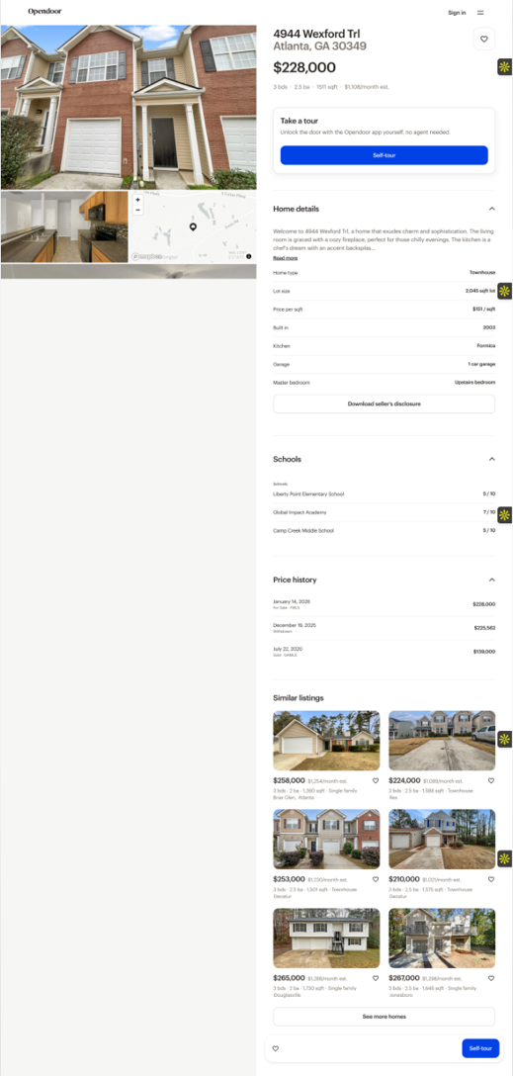 <https://www.opendoor.com/>

Clean UI with cost mapping.

Clean Cards: Keep the offering cards simple, 50% photo, white background, and highlight just one big number (like 15.54% IRR).

Interactive Map: When a user hovers over a property card, the corresponding map pin must bounce or light up instantly to show location context.

Visual Data, Not Tables, progress rings or simple icons for metrics like Occupancy or Funded % to make the data feel friendly UI.

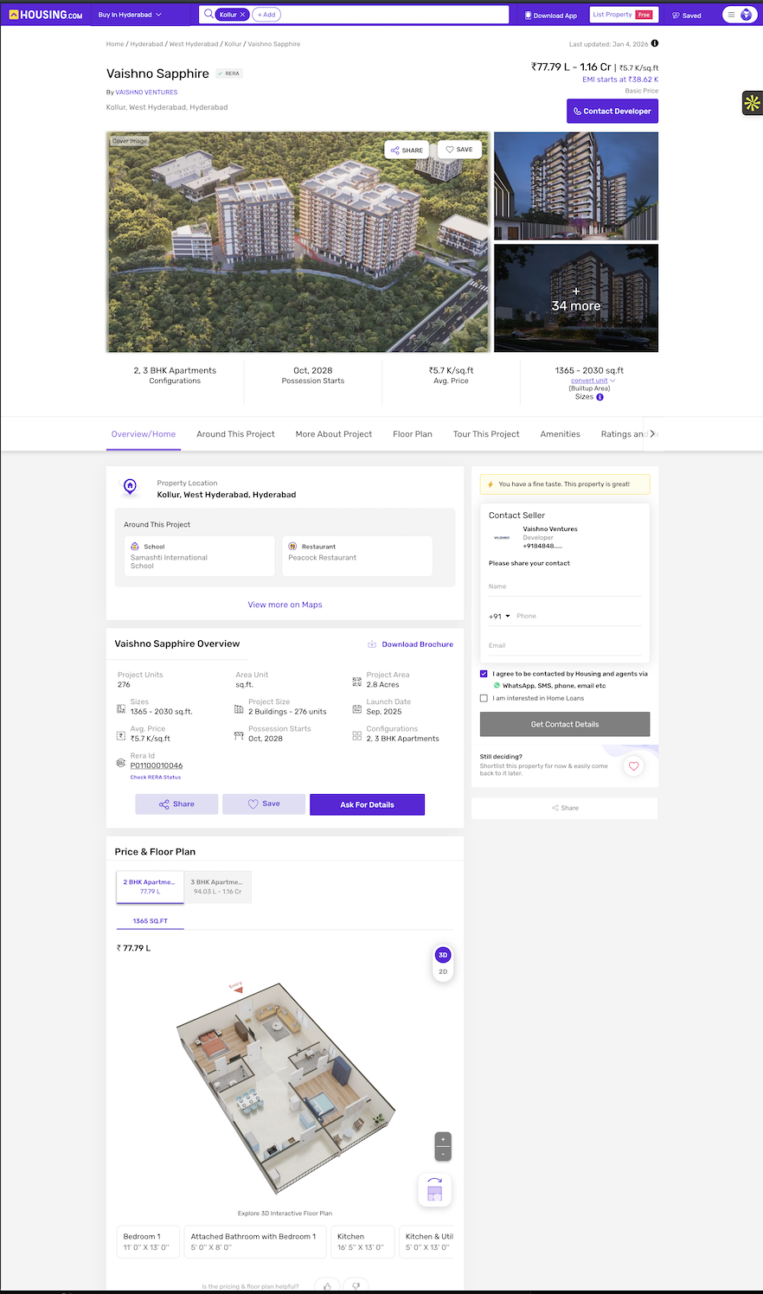www.housing.com

We should use a huge photo with no text on top because it looks premium and then place the big numbers like IRR and equity multiple in a clean white bar right underneath so they are the first thing people see

It helps to have a menu bar that stays stuck to the top of the screen as you scroll down so users can jump straight to the documents or financials without getting lost in the long text

We need to make sure the invest button stays locked on the right side of the screen while people read the story so they can click it the exact moment they decide to move forward

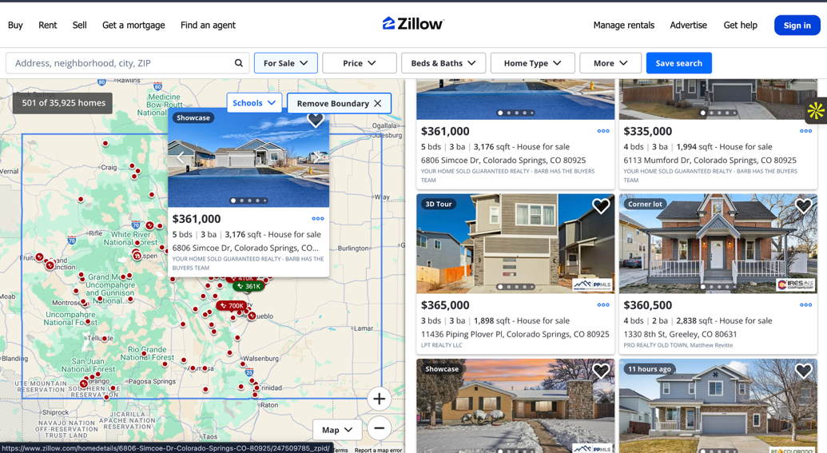

When users click a document, instead of just downloading it, open it in a nice full-screen preview window so they can scroll through it easily right on the page.

For the really important stuff like financial reports, we should put a gate on it. So when they click, a simple popup asks for their info first, and then the document unlocks immediately.

We need to mark the gated files with a little lock icon so people know they are valuable, while the basic brochures can just be open for everyone.

x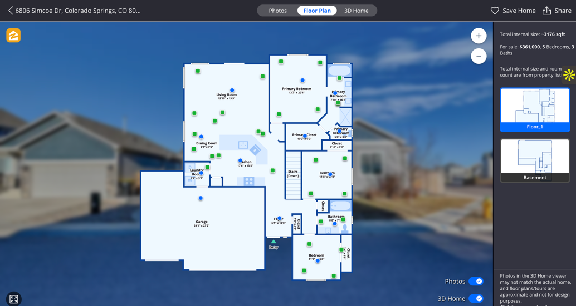

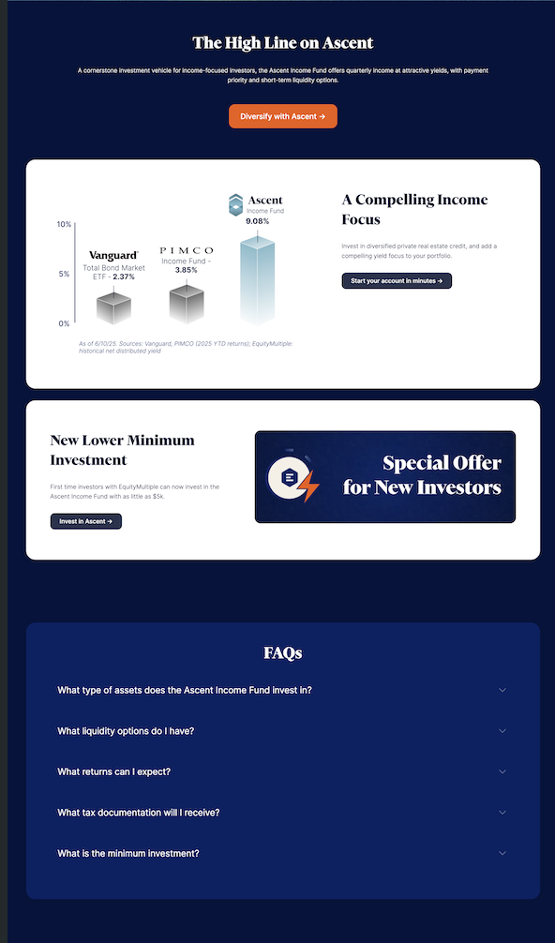<https://equitymultiple.com/ascent>

<https://www.willowwealth.com/360>

=====================================================